9,6 or 24/25

|  |
| --- |
| > install.packages("irtoys")  Installing package into ‘C:/Users/Lenovo/Documents/R/win-library/3.1’  (as ‘lib’ is unspecified)  trying URL 'http://cran.rstudio.com/bin/windows/contrib/3.1/irtoys_0.1.7.zip'  Content type 'application/zip' length 128823 bytes (125 Kb)  opened URL  downloaded 125 Kb  package ‘irtoys’ successfully unpacked and MD5 sums checked  The downloaded binary packages are in  C:\Users\Lenovo\AppData\Local\Temp\Rtmpu87htC\downloaded_packages  > library("irtoys")  Loading required package: sm  Package 'sm', version 2.2-5.4: type help(sm) for summary information  Loading required package: ltm  Loading required package: MASS  Attaching package: ‘MASS’  The following object is masked from ‘package:sm’:  muscle  Loading required package: msm  Loading required package: polycor  Loading required package: mvtnorm  Loading required package: sfsmisc  > getwd()  [1] "C:/Users/Lenovo/Documents"  > rasch_model<- est(Scored, model="1PL", engine="ltm", rasch = TRUE)  > est_params <- est(Scored, model="1PL", engine="ltm", rasch = TRUE)  > est_params <- rasch_model$est  > colnames(est_params) <- c("Discrimination", "Difficulty", "Guessing")  > rownames(est_params) <- paste("Item", 1:18)  > est_params  Discrimination Difficulty Guessing  Item 1 1 -1.40938612 0  Item 2 1 -0.35055656 0  Item 3 1 -0.90318970 0  Item 4 1 -0.97412011 0  Item 5 1 -1.62671110 0  Item 6 1 0.02533657 0  Item 7 1 -0.41418545 0  Item 8 1 -0.87993298 0  Item 9 1 -0.91498121 0  Item 10 1 0.52959427 0  Item 11 1 -1.17125435 0  Item 12 1 -0.04749604 0  Item 13 1 0.15008663 0  Item 14 1 -0.74253017 0  Item 15 1 -0.74245332 0  Item 16 1 0.36963876 0  Item 17 1 -0.84513136 0  Item 18 1 -1.45145349 0  > est_es <- rasch_model$se  > colnames(est_se) <- c ("Discrimination SE", "Difficulty SE", "Guessing SE")  > rownames(est_se) <- paste ("Item", 1:18)  > est_se  Discrimination SE Difficulty SE Guessing SE  Item 1 NA 0.1267448 0  Item 2 NA 0.1128011 0  Item 3 NA 0.1178581 0  Item 4 NA 0.1188426 0  Item 5 NA 0.1320051 0  Item 6 NA 0.1118476 0  Item 7 NA 0.1131572 0  Item 8 NA 0.1175527 0  Item 9 NA 0.1180162 0  Item 10 NA 0.1136598 0  Item 11 NA 0.1220123 0  Item 12 NA 0.1118797 0  Item 13 NA 0.1119630 0  Item 14 NA 0.1159197 0  Item 15 NA 0.1159189 0  Item 16 NA 0.1126941 0  Item 17 NA 0.1171115 0  Item 18 NA 0.1276902 0  > plot(irf(est_params[c(1,3,5),]), co = NA)  > est_abl <- as.data.frame(mlebme(Scored, ip = est_params))  > min(est_abl$est)  [1] -3.999947  > max(est_abl$est)  [1] 3.999921  > which.min(est_abl$est)  [1] 393  > which.max(est_abl$est)  [1] 49  > est_abl[200,]  est sem n  200 -0.6390908 0.492458 18  > plot(iif(est_params[c(1,3,5),]), co = NA)  > plot(tif(est_params))  > twopl_model <- est(Scored, model="2PL", engine="ltm")  > twopl_params <- twopl_model$est  > colnames(twopl_params) <- c("Discrimination", "Difficulty", "Guessing")  > rownames(twopl_params) <- paste ("Item", 1:18)  > twopl_params  Discrimination Difficulty Guessing  Item 1 0.6326689 -2.00058101 0  Item 2 1.5469622 -0.26815483 0  Item 3 1.2534918 -0.77297206 0  Item 4 0.9842598 -0.97706755 0  Item 5 1.6407242 -1.19389580 0  Item 6 1.4702029 0.01833431 0  Item 7 0.5632837 -0.65124651 0  Item 8 2.2881772 -0.56753253 0  Item 9 1.8004066 -0.64761748 0  Item 10 1.1142107 0.48542889 0  Item 11 1.0344119 -1.13363005 0  Item 12 0.3329130 -0.12951933 0  Item 13 0.3369968 0.36344671 0  Item 14 0.6608229 -1.01479867 0  Item 15 1.5980393 -0.55640285 0  Item 16 1.0362116 0.35459121 0  Item 17 1.8591845 -0.59017915 0  Item 18 1.2808752 -1.22177042 0  > twopl_abl <- as.data.fram(mlebme(Scored, ip = twopl_params))  Error: could not find function "as.data.fram"  > twopl_abl <- as.data.frame(mlebme(Scored, ip = twopl_params))  > cor(twopl_abl$est,est_abl$est)  [1] 0.9709497  > plot(iif(two_params[c(3,6,9),]), co = NA)  Error in iif(two_params[c(3, 6, 9), ]) : object 'two_params' not found  > plot(iif(twopl_params[c(3,6,9),]), co = NA) |
| |  | | --- | |  | |

|  |
| --- |
|  |

**Question 1**

1. The easiest item is question no. 5, -1.63 and the hardest item is question no. 10, 0.53.
2. 95% confidence interval.

For the easiest item: -1.63 + 1.96 * 0.13 = -1.37 (the upper bound) and -1.63 – 1.96 * 0.13 = -1.88 (the lower bound). It can be said that with 95% confidence that the true item difficulty for the easiest item is between -1.88 and -1.37. -.5

1. Plot for the easiest item in black (q5) and the hardest item in red (q10).

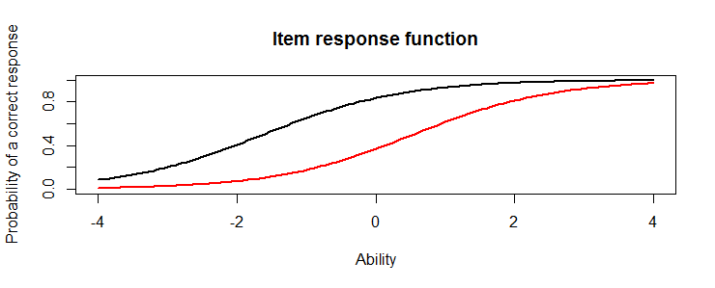

1. The probability of a correct response would be ~ 0.8 for someone who had the ability score of 0 for the easiest item and ~ 0.3 for someone who had the ability score of 0 for the hardest item.
2. The score of the person who did best on the test was: 3.99. The score of the person who did worst on the test was: -3.99.
3. 3.99 + 1.96 * 2.20 = 8.30. 3.99 – 1.96 * 2.20 = -0.32.

With 95% confidence it can be said that person´s true ability with the best score on the test is between -0.32 and 8.30. -.5

**Question 2 – information**

1. I selected items no. 3, 6 and 9.
2. Information plot for the items 3, 6 and 9.

|  |
| --- |
|  |

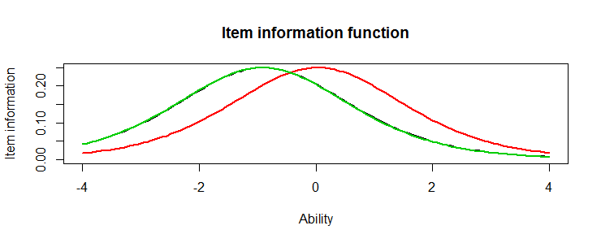

1. The same about these items are: firstly; two items have the same shape (green and black). So a person´s ability on those two items are the same and the discrimination is the same. The red item is different from the other two items and the red item is also harder item than the green and black items. The majority of ability scores for the green and the black item is closely between -2 and 0. And the majority of a ability score for the red item is closely between -1 and 1. The discrimination in peoples ability is not very informative.
2. Plot of the test information function:

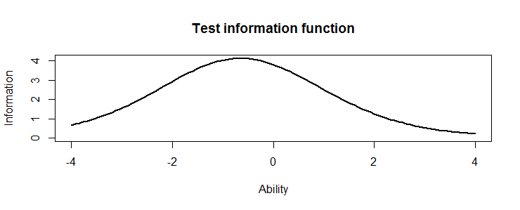

1. The majority of the infromation for this test is located closely between -1.5 to 0.2.

**Question 3 – Comparing the 2-PL**

1. For the 2-PL model; the highest discrimination was item 8 = 2.29 and the lowest discrimination was item 12 = 0.332.
2. Comparing the easiest and hardest items in the Racsh model and the 2-PL model; the hardest items was the same for both models, item 10. In the Rach model it was 0.53 and in the 2-PL model it was 0.48, but the easiest items was not the same for the models. The easiest item in Rasch model was – 1.63 for item 5 and – 2.00 for item 1 in the 2-PL model.
3. The correlation between the ability estimates on the Rasch model and the 2-PL is 0.97, wich is very high; almost perfect (1.0). Based on this high correlation the same conclusions could be drawn from both models. This high correlation shows that person´s ability is very alike between these models. If a person´s ability is high on the Rasch model it is also high on the 2-PL and the same for person´s low ability, it would be low on both the Rasch model and the 2-PL model.

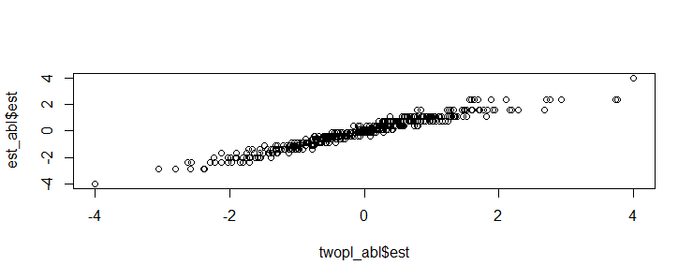

1. Plot of the item information function for items no. 3, 6 and 9, in 2-PL model.

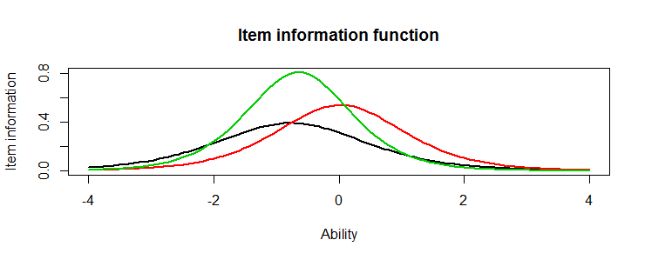

1. How do the item information functions differe for these items in 2-PL model comparing to the Rasch model.

First; the Rasch model only provide the item location/difficulty. While the 2-PL model, provides both item location/difficulty as well as item discrimination. Now the green and black items are different from each other.

The black item provides very little information, with very low peak. The majority of information are located closely between -1.8 and 0.3. The information for this item are not useful.

The red item provides more information than the black item, with higher peak. The majority of information are located closely between -0.7 and 0.8. The red item is the one most difficulty of those three items, with item difficulty more locaded to the right tail, but the discrimination is not as good as for the green item.

The green item provides the best informations of these three items, with the highest peak and provide the best discrimination of the three items. The majority of information are located closely between -1.0 and -0.2, indicating that the item is a good predictor for those scoring in that range.